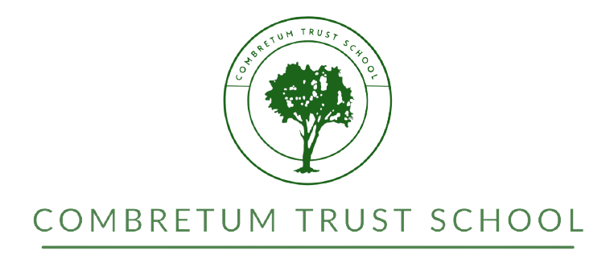

Application Form: 2022
Please Note: Completion of this form will put your child’s name on a waiting list only. We will then keep in contact with you and let you know if the class is becoming full.
If you have already decided that this is the school you wish your child to attend in 2022 and want to guarantee a place you need to:
- Pay the non-refundable registration fee
- Complete the more detailed registration form

SECTION A: Information about lEARNER
Grade applied for in 2022
Surname |  |  |  |  |  |  | First Names
Date of Birth |  |  |  | Nationality |  |  |  |  |  |  |  |  |  | Gender
Present School |  |  |  |  |  |  |  |  |  |  |  |  |  | Grade
Mother Tongue |  |  |  |  |  |  |  | Other Languages Spoken
Diagnosed Learning Disabilities

section b: information about parent/guardian
Surname |  |  |  |  |  |  |  |  |  | First Names:
Relationship to learner
Employer
Position held at workplace
Postal Address

Physical Address

Cell Phone Number
Work Telephone Number
Fax Number
Home (landline) Number
E-mail Address
Finally please let us know how you heard about this school
Advertisement |  |  |  |  |  | Friend or Family |  |  |  |  |  | Other
If someone recommended us to you, please let us know who this was

Please note that interviews are necessary for non-Namibians in all grades, for learners who have been asked to leave previous schools, and for all learners applying for senior grades . Appointments must be made through the school secretary +264 081 286 2864 or Email: combretumschool@gmail.com

